**Setting up Application Environment**

**Docker CLI Installation**

|  |  |
| --- | --- |
| **Team ID** | PNT2022TMID36945 |
| **Project Name** | Inventory Management System |
| **Date** | 20 October 2022 |

**Step 1:** Download Docker from docker.com and install it by running the Docker Desktop Installer.exe file

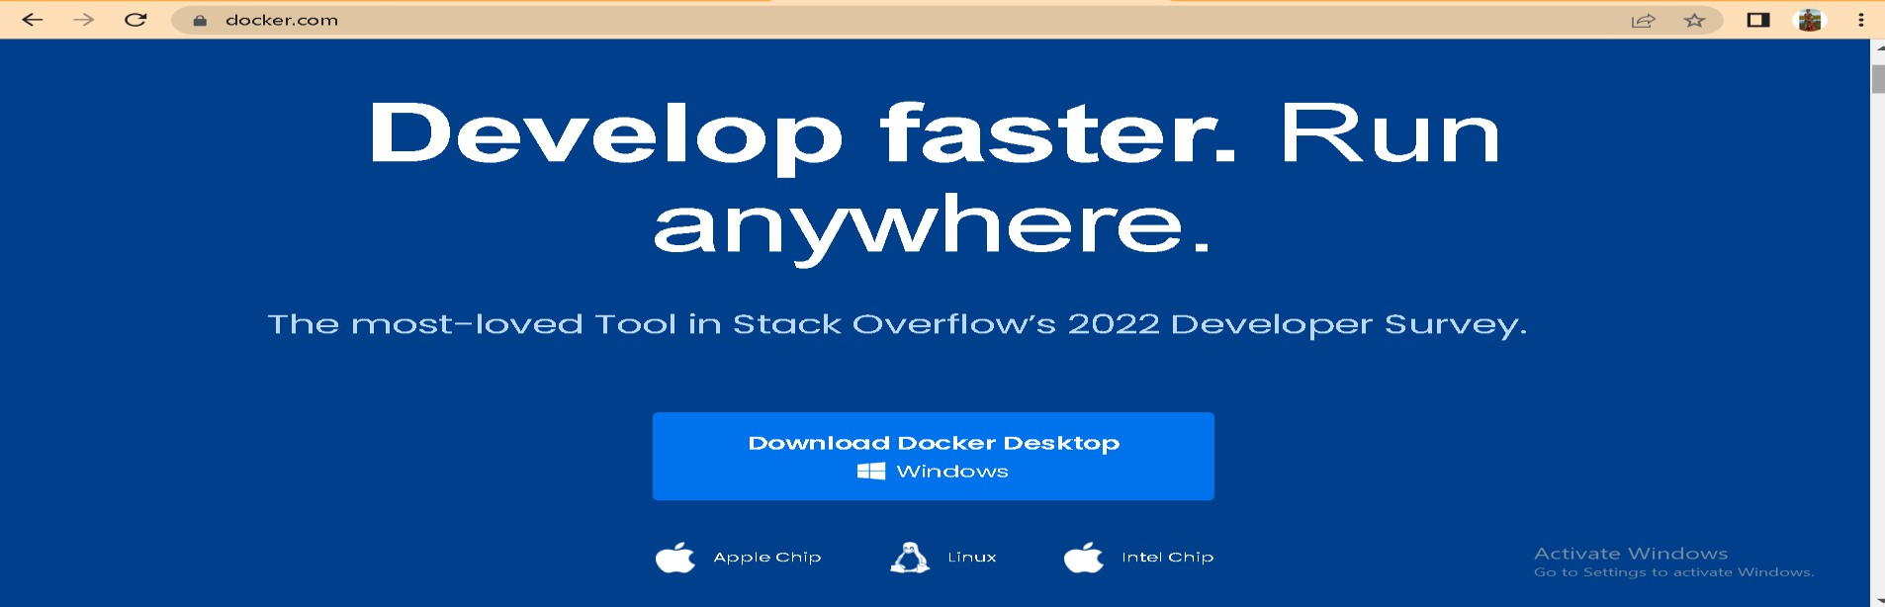

**Step 2:** Go to hub.docker.com register and create an account and login with the same

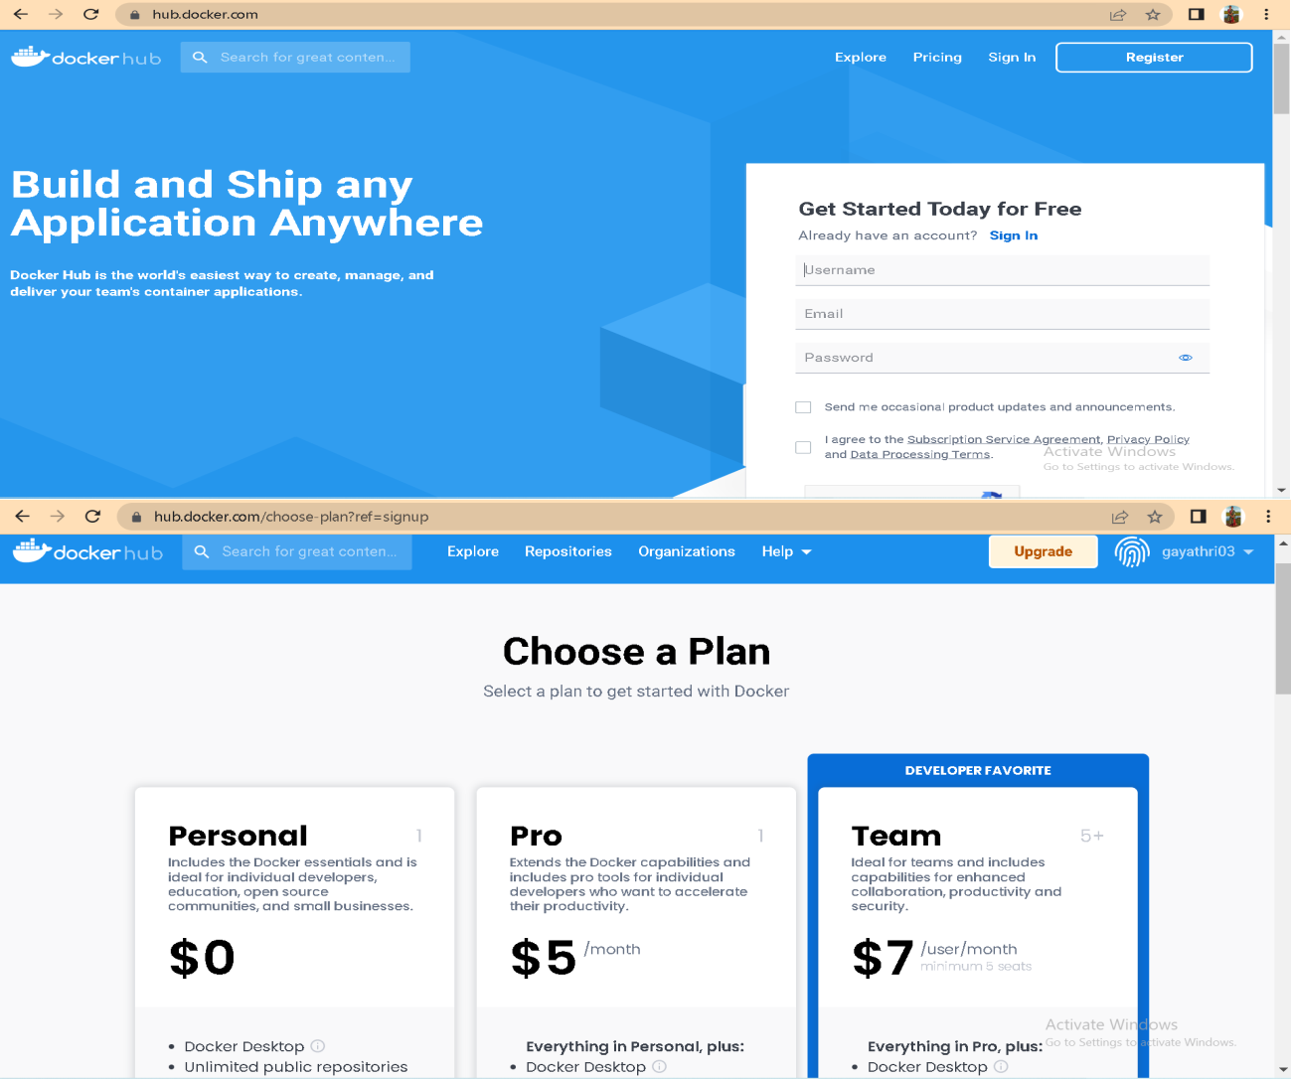

**Step 3:** Open Docker Desktop and start creating containers and images

